If Eastman Were Alive Now
Sometime back I wrote an article arguing how Kodak lost focus on its vision and went from one of the most significant companies in the world to a small provider of a niche product (How Kodak Went So Wrong – January 23, 2015). The basic premise of that argument is that if Kodak had kept true to George Eastman’s original motivation for producing photographic film – namely that he wanted to enable people to ‘capture memories’ as easily as possible and film was the means to that end during his lifetime – then Kodak would have transitioned to digital and remained a world business leader. The movement from film to CCD-based digital ‘memory capturing’ in the 1980s would have been as logical a progression as the transition from plate-photography to film had been in the 1880s.
From a purely economic perspective, the current COVID-19 pandemic is providing valuable insight into how companies are positioned to either rise or fall based on their business savvy and agility in adapting to these dynamic and unpredictable events as they unfold. Economists and business analysts will be able to write papers for decades to come examining each and every sector of the economy.
That said, this post will engage in a little alternative history and counter-factual conjectures in asking what would the modern landscape look like if Kodak had been able to hold on to the business sense and entrepreneurial spirit that George Eastman had in such abundance. To this we are going to make an admittedly radical assumption in imagining that Kodak’s chemistry wing managed to produce a fountain-of-youth serum that only worked on its founder.
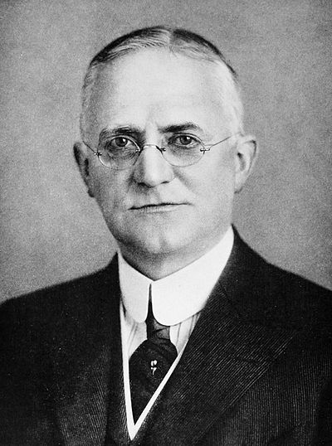
By Published by B. C. Forbes Publishing Company, New York, 1917 - https://archive.org/details/menwhoaremakinga00forb, Public Domain, https://commons.wikimedia.org/w/index.php?curid=19172293
Our alternative-universe story begins in 1929 when George Eastman was is 75 years old. While tinkering on improved roll film, Kodak’s chemical division accidentally creates a noxious compound whose merest whiff causes violent headaches, nausea, and vomiting. Trying to isolate what happened the lead chemists realize that they can’t quite duplicate the experiment but that what they’ve created is a highly volatile and potent poison.
Learning about the lab accident, our alternative Eastman, who is already beginning to suffer from the spine ailment that would drive the real Eastman to suicide in 1932, decides that if he is to take his own life that he would prefer to do so with this one-of-a-kind toxin that his company has produced. Sneaking into lab late at night, Eastman quaffs the poison and collapses, thinking, as he loses consciousness, that the end is nigh.
Imagine his surprise when he awakens hours later, his spinal pain completely gone and his age regressed until he looked and felt as he did in his mid-thirties, around the age when he had developed the Kodak Black camera. Restored to his prime with vigor to spare, he resumes his role of steering on one of the largest companies of his time.
Now filled with inexhaustible youthful vigor, he tackles the new technology of that era: quantum mechanics. His long-standing interest in chemistry is supplanted by this new science that underlies it. It’s a slow go but just as he is starting to master the subject conceptually, World War II breaks out.
Under his leadership, Kodak supplies aerial photographic support to the Allies Intelligence apparatus. After the war, Eastman has the company build upon the technical innovations it produced during the war and the good will that came with serving the country during its time of need, further positioning Kodak as a go-to company that makes life better.
Now believing that an even better experience awaits his consumer base, Eastman has Kodak develop a research branch focusing on the science of optics and electronics. He backs a partnership with Bells Labs and directs his technical staff to stay abreast of developments in the field.
The critical juncture takes place about 25 years after the end of the war. Like in our own timeline, the late 1960s find Boyle and Smith making the first charge coupled device at Bell Labs, followed shortly after by Steven Sasson, a Kodak employee, developing and patenting the first CCD-base camera in 1975. However, unlike our own timeline, with Eastman at the helm, Kodak quickly jumps on commercialization and begins to gather market share with its digital photography.
In 1984, the alternative timeline Kodak eagerly agrees to the official film of the Los Angeles Olympics. This move allowed Kodak to keep rival Fujifilm at bay while also enabling the corporate giant to again use favorable public sentiment to its advantage in promoting its new digital photography offerings.
The time of crisis now passed, Kodak then steam rolls into the modern era. Eastman’s vision of putting ‘the what’ (capturing memories) before ‘the how’ (photographic film) allows Kodak to nimbly respond to the ever more rapidly changing market.
By the late 1980s, Kodak has partnered its CCD-based technology with Sony to make a consumer camcorder second to none. By the 1990s, recognizing how the internet would allow a person to share the memories he had captured with Kodak cameras, Eastman guides the company to invest heavily in the internet. Kodak develops, patents, and licenses streaming technology years ahead of what was developed in our own timeline. By the mid 2000s, Kodak, now recognizing the move towards miniaturization and consolidation desired in the consumer telecom industry, beats Apple to the invention of the smartphone. Finally, capitalizing on the growth of broadband internet and increasing speeds, this alternative Kodak corners the market on teleconferencing and collaborative applications like Zoom, Webex, or Adobe Connect.
When the COVID-19 crisis hits this alternative timeline, Kodak, already a household world, is able to further cement its reputation in the eyes of the consumer as the company that helps make, capture, and share memories with each other while staying safe.
While it is true that the foregoing is a work of hypothetical fiction with no way to either prove or disprove its veracity, it is also certainly true that at least some of the events narrated would have actually been within the Kodak’s grasp had they simply kept true to the vision of George Eastman.

